# Trace Report 3– Abhimanyu bhat – 11732514- ass 4

## Tracing the third bug – pay fine – incorrect fines owed

The fines owed are shown as double the actual amount.

1. The screenshot shows the starting point of the bug. It is in the **payFine** method of the Main class.

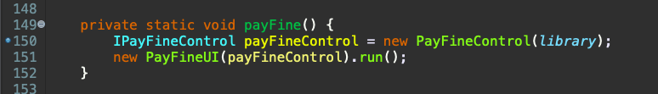

2. This screenshot shows the error.

We can see that the due date is the 25th of October 2020 and the fine is calculated as $3.00. But even though there are no book damages, the value of Fines Owed has doubled.

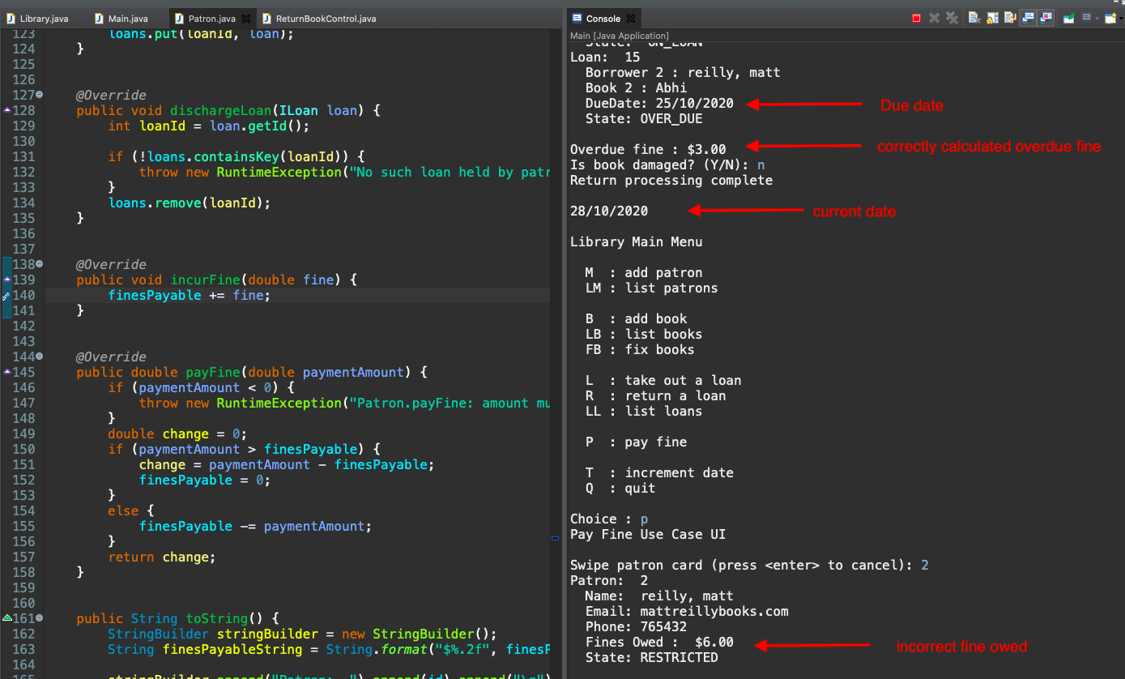

3. Next, we see the breakpoints that have been placed in all the various classes. These are in **dischargeLoan** in Library class, in payFine in Main and in **incurFine** in **Patron** class.

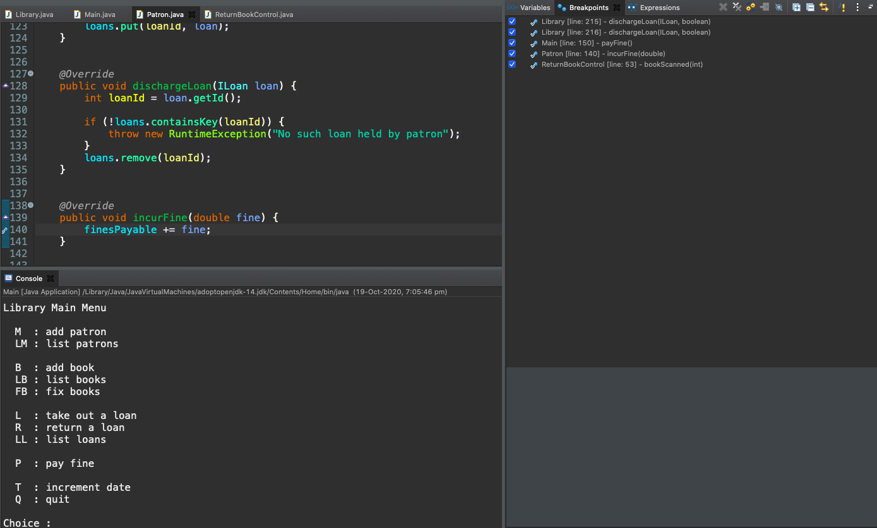

4. Trace report: The following screenshots show the trace of the breakpoints.

Trace 1: We see the value of overDueFine is $5.00 which is correct.

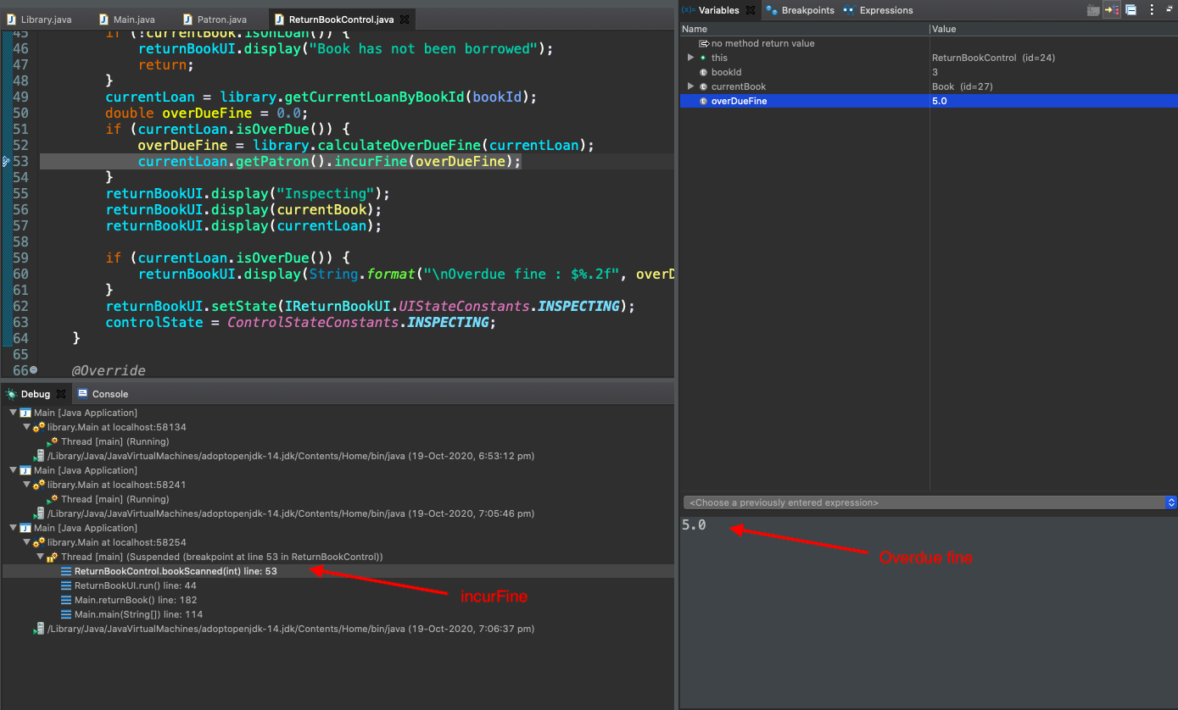

Trace 2: We can see that in the Patron class the fine is $5.00

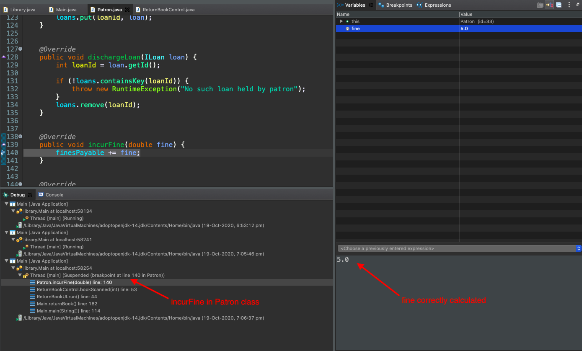

Trace 3: We can see that overdue fine is correctly displayed.

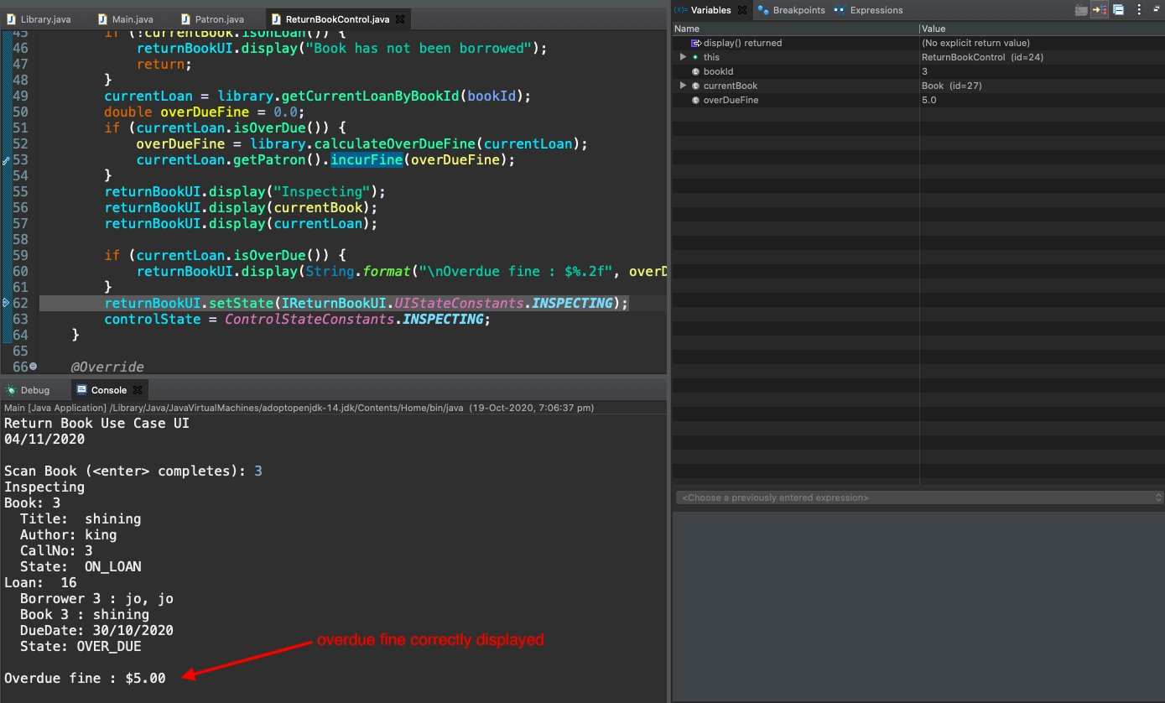

Trace 4: We now go into the Library class.

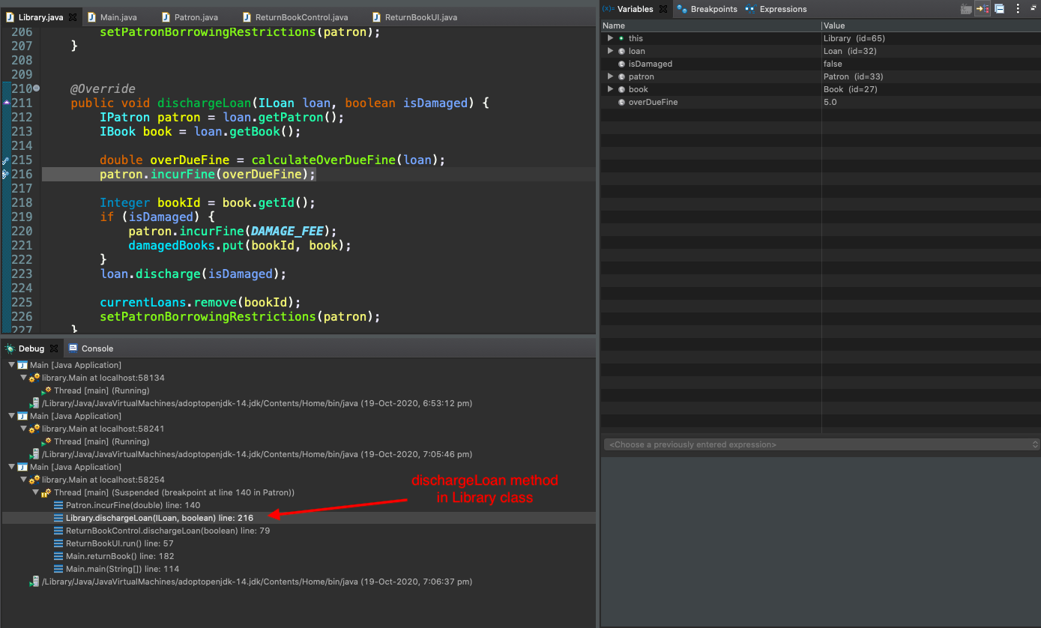

Trace 5: We can see the user has input ‘p’ to pay their fine

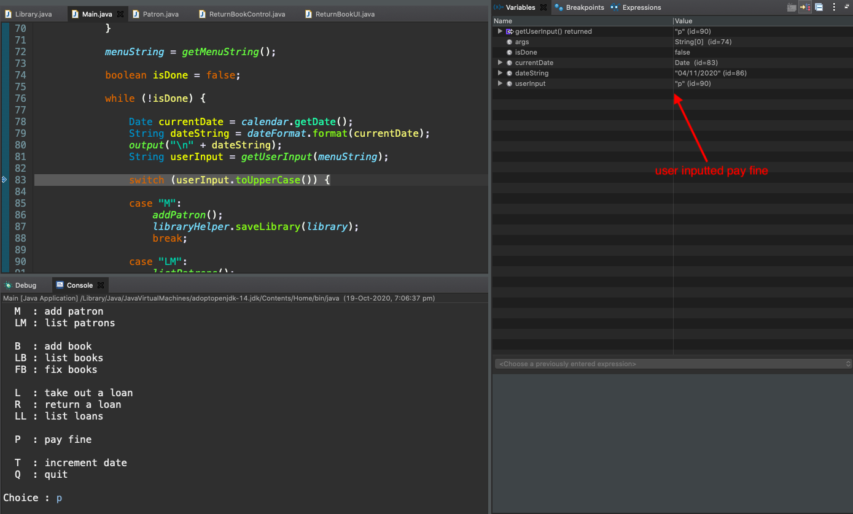

Trace 6: The amount of fine is incorrect and is double the actual amount.

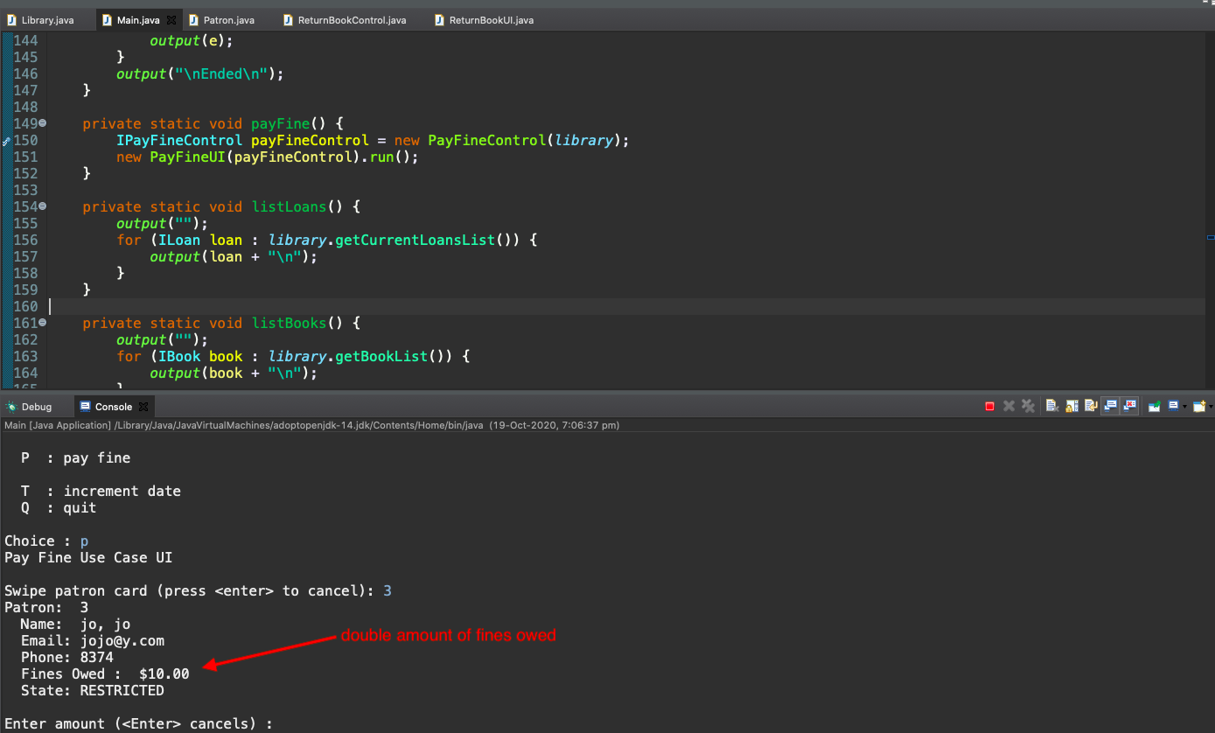

Trace 7: The **finesPayableString** from the screenshot below shows the incorrect fine owed.

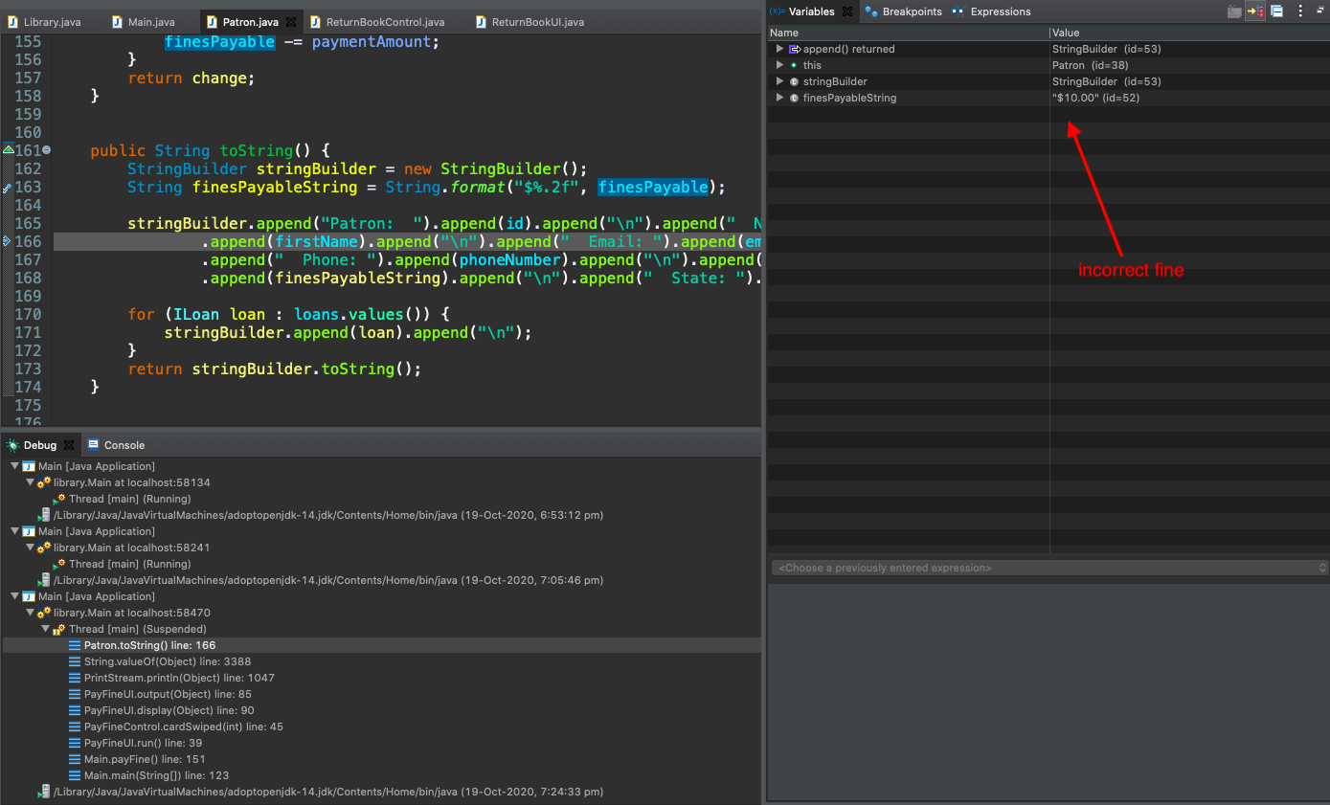

5. Hypotheses

I can see that the amount of fine has been doubled even though the book is not damaged. So I try to comment out the calculation of **incurFine** in the **dischargeLoan** twice.

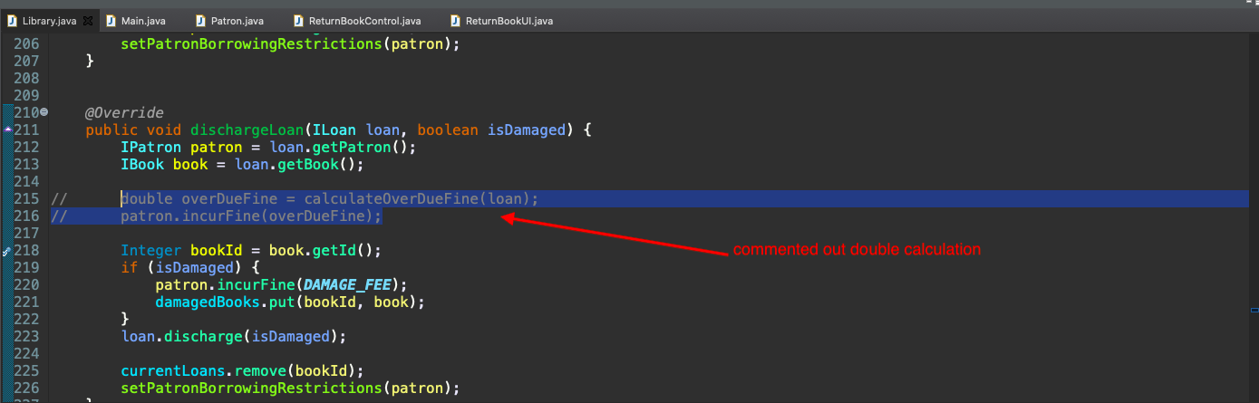

6. Solution

After commenting out the code we can now see that the **finesPayableString** is now the correct value.

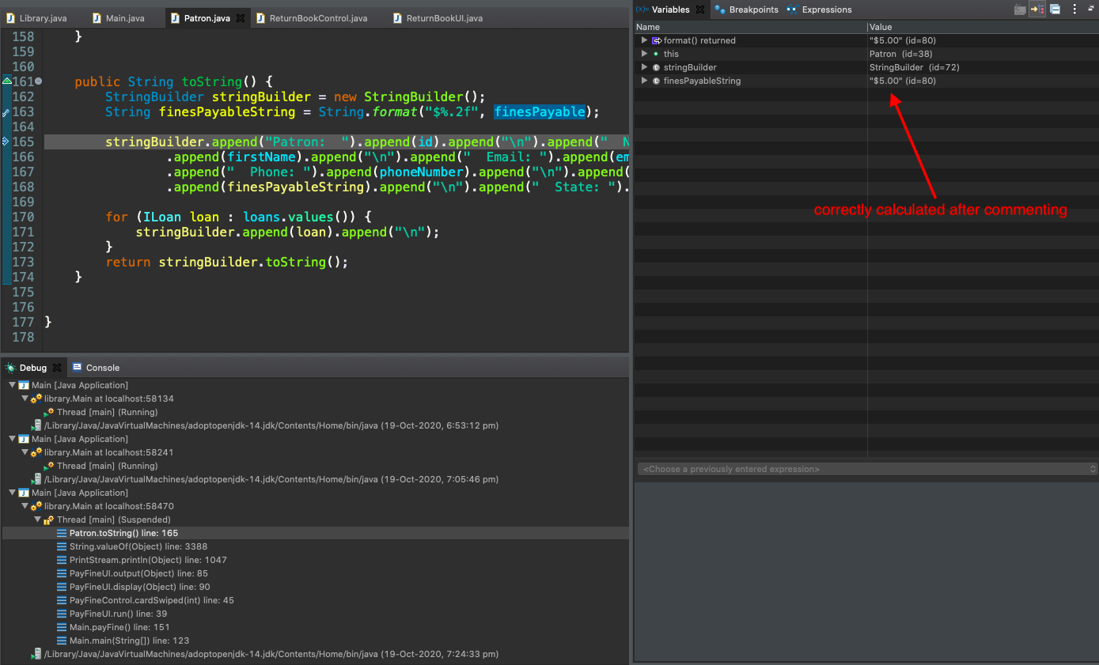

Output:

The below screenshot shows the solution. The Overdue fine and Fines Owed have the same value.

